Sanjel: EService to Ax Movement Journal

Required Fields

# Introduction

Sanjel requested that NTT Data investigate the possibility of automating the flow of information from EService to Ax Movement Journals. As part of this due diligence, an outline of the fields that are required is needed. It is understood that the data will be migrated to the Journals, but that Posting will remain in the hands of the users.

# Journal Structure

The journal is composed of 2 sections: a header and a body. The body is a collection of line items that must contain at least 1 record. There appear to be 2 columns that were added to the Journal Header as customizations.

# Header Required Fields

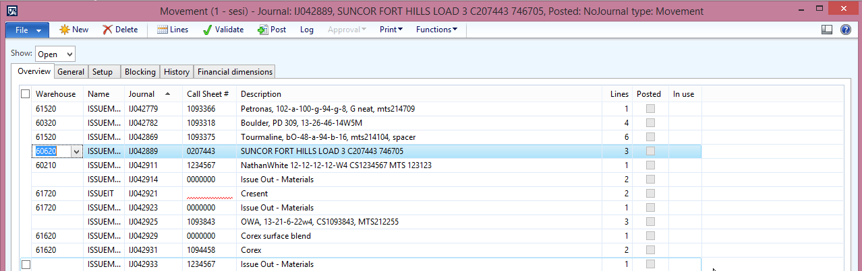

The following fields are required:

* Warehouse: Supplied by EService
* Name: Fixed Value
* Journal (Id): Generated by the System
* Call Sheet#: Supplied by EService
* Description: Supplied by EService CG: need to talk to Colin about what to put here.

# Body Required Fields

## General

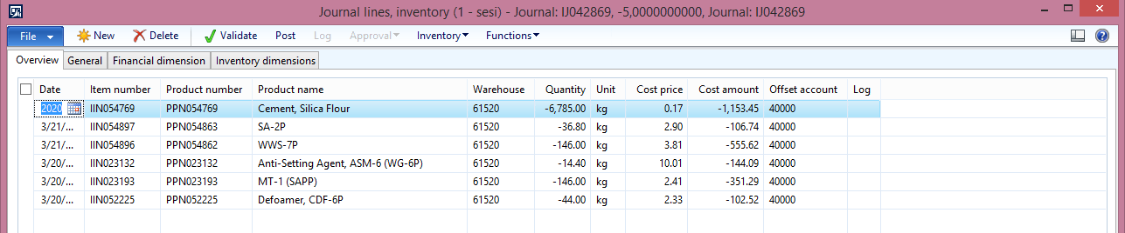

* Date: Supplied by EService
* Item Number (Id): Supplied by EService
* Product Number: Supplied by Ax
* Product Name: Supplied by Ax
* Warehouse: Suppled by EService (If it can be different from the header. Otherwise, use the header) CG: Bulkplant where blended
* Site: Supplied by EService CG: Bulkplant where blended

## Inventory Dimensions

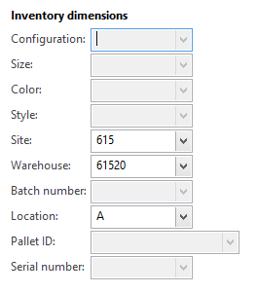

* Location: Supplied by Eservice CG: Default to A or Blank?
* Quantity: Supplied by EService
* Unit: Supplied by EService CG: need to be cautious, AX and eS use different units of measure for cement, in AX cement products are in Tonne, everything else in kg or litre.
* Cost Price: Supplied by Ax
* Cost Amount: Supplied by Ax
* Offset Account: Supplied by EService (unless it is a fixed value) CG: What is this?

## Financial Dimensions

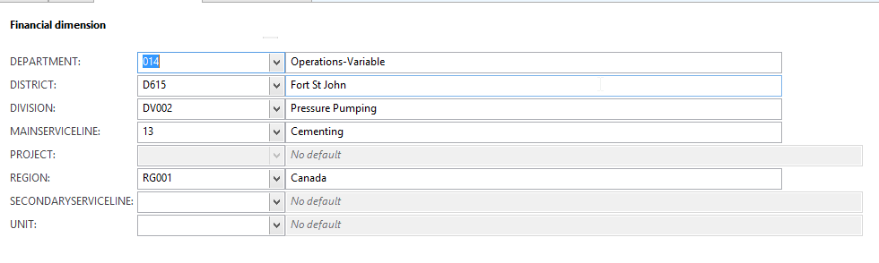

* Department: Supplied by EService (unless it is a fixed value) CG: default to 014
* District: Supplied by EService (unless it is a fixed value) CG: Equal Service point in eService
* Division: Supplied by EService (unless it is a fixed value) CG: Default to DV002
* Main Service Line: Supplied by EService (unless it is a fixed value) CG: value based on Job Type
* Project: Does not appear to be used CG: not used
* Region: Supplied by EService (unless it is a fixed value) CG: Default to RG001
* Secondary Service Line: Supplied by EService (unless it is a fixed value) CG: value based on Job Type
* Unit: Supplied by EService (unless it is a fixed value) CG: Not used for materials movement journal